DLAP Events Deployment Guide

Change History

| Version # | Date | Modified By | Description |
| --- | --- | --- | --- |
| 2.0.0.0 | 03/19/2018 | Ashok Pudota | Initial DLAP Events Deployment |
| 2.0.0.1 | 04/23/2018 | Ashok Pudota | Updated Deployment Version from 2.0.0.0 to 2.0.0.1.  Updated Document and Status mapping. |
| 2.0.0.2 | 05/12/2018 | Ashok Pudota | Updated Deployment Version from 2.0.0.1 to 2.0.0.2.  Updated Status mapping. |
| 2.0.1.0 | 05/30/2018 | Ashok Pudota | Updated Deployment Version from 2.0.0.2 to 2.0.1.0.  Updated Events Logic to process multiple request.  Fixed Document and Status Mapping. |
| 2.0.8.1 | 08/27/2018 | Ashok Pudota | Updated Deployment Version from 2.0.1.0 to 2.0.8.1.  Removed CDATA Ports except event request |
| 2.0.9.10 | 10/24/2018 | Ashok Pudota | Updated Deployment Version from 2.0.8.1 to 2.0.9.10  Fixed Following Issues:  DCMM-5825 |

**Contents**

1. **Special Notes……………………………………………………………………………………………………………………….2** 
   1. **Username and Password instructions……………………………….…………………………………….2**
2. **Initial Deployment instructions ……………………………………………………………………………………………3**
3. **Re-Deployment** **instructions………………………………………………………………………………………………….6**

Special Notes:

Update Oracle Username and Password in the Binding File

Initial Deployment Summary:

**Msi Installation:**

1. Open BizTalk Administration console and Import/Install the **DLAP Events2.0.0.0msi** into the **Small Business Administration** application then complete the wizard by clicking Finish button and check mark the option Run Application Installation Wizard again to Install the MSI.
2. Next, import the **DLAP Events Binding Info.xml** binding file after updating **Salesforce** send port configuration into the **Small Business Administration application.**
3. Start all the BizTalk artifacts related to **DLAP Events as shown in the below screenshot**.

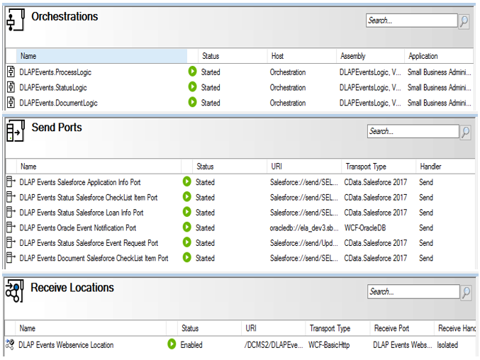

1. **Restart** All the **Host-instances.**
2. Open **IIS** (Internet Information System) right click on **DLAP Events** Website and validate appropriate **Application Pool** (i.e. **DLAP Events**) is selected.
3. Reset/Re-start **IIS** (Internet Information System).
4. Browse the following **DLAP Events** (HTTPS://) Website and make sure the site is up-running.

**Validate Application Being Deployed:**

1. Go to **BizTalk Administrator Console**, make sure **all** BizTalk artifacts related to **DLAP Events Interface** are up-running.
2. Go to **IIS**, make sure IIS is started.
3. Browse the **DLAP Events** web site (HTTPS://) and make sure the site is up-running.
4. Open Soap-UI project attached on Deployment folder and post the sample message.

Re-Deployment instructions:

**Msi Installation:**

1. Go to BizTalk Administration console **stop and Unenlist all** the BizTalk artifacts related to **DLAP Events Interface:**

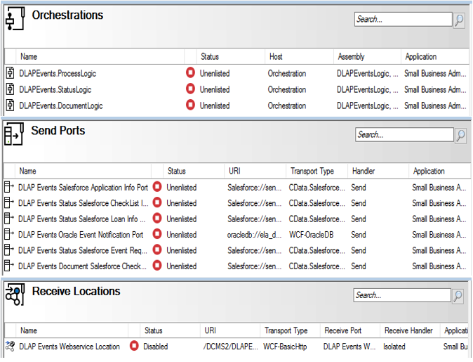

1. **Remove all the assemblies Version 2.0.0.1 and web- directory dlls as shown below**

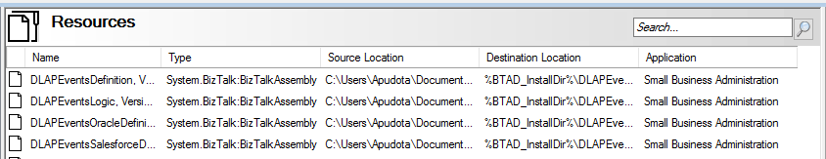

1. Ports Cleanup (**Unenlist and Remove following CDATA send ports**):

*DLAP Events Status Salesforce Loan Info Port*

*DLAP Events Status Salesforce CheckList Item Port*

*DLAP Events Salesforce Application Info Port*

*DLAP Events Document Salesforcet Content Version Port*

*DLAP Events Document Salesforce CheckList Item Port*

1. Next, Open **BizTalk Administration console** and **Import/Install** the **DLAP Events 2.0.0.2.msi** into the **Small Business Administration** application then complete the wizard by clicking **Finish** button and check mark the option **Run Application Installation Wizard** again to Install the MSI.
2. Next, import the **DLAP Events Binding Info2.0.0.0.xml** binding file after updating **Salesforce** send port configuration into the **Small Business Administration application.**
3. **Start** all the **BizTalk artifacts (i.e. Receive location, Send ports and Orchestration)** related to **DLAP Events** Interface.
4. **Restart** All the **Host-instances**.
5. Open **IIS** (Internet Information System) right click on **DLAP Events** Website and validate appropriate **Application Pool** (i.e. **DLAP Events**) is selected.
6. **Reset/Re-start IIS** (Internet Information System).
7. Browse the following **DLAP Events** (HTTPS://) Website and make sure the site is up-running:

**Validate Application Being Deployed:**

1. Go to BizTalk Administrator Console, make sure **all** BizTalk artifacts related to **DLAP Events** Interface are up-running.
2. Go to IIS, make sure IIS is started.
3. Browse the DLAP Events web site (HTTPS://) and make sure the site is up-running.
4. Open Soap-UI project attached on solutionItems folder and post the sample message.